Beer Name: Crank biter bitter
Brew Date: Apr 9’18
Batch Size: 10 gal
Target OG/◦ 1.046
Amnt lb/kg Ingredient
11 # ESB
3 # Crystal 20L
3 # Victory
1 # Wheat
1 tsp NaCl(mash)
1 tsp NaCl(sparge)
4 tsp supercharge
1 tabs irish moss

Qt oz/g Hop/Seasoning Time

65 g NB 60min
30 g Golding 30min
30 g Golding 15min
1 tabs irish moss
Stage Date
Primary:
Racked:
Racked:
Bottled:
Kegged:
Re-Kegged:
Purged: Charged:

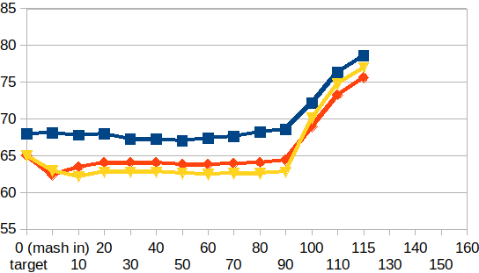
Start Time: 7:15am
Fill mash tun: Fri
Fill sparge kettle: Fri
Fire burners: 7:15am
Heat Mash Tun : Target Temp: 64
Heat Sparge Kettle: Target Temp: 68
Target Temp (Mash): 64
Grind grain: 8:05am
sparge temp:68.1
Strike Temp: 64.1
pump temp: 65
Temp: 64.2
Mash: Duration: 90 minutes
Start: 8:40am Finish:10:10am
Heat (to deactivate enzymes)
Target Temp: 75.5
Start: 10:10am
Finish: 10:35am
Heat Sparge H20 (Target80◦)
Sparge: Start: 10:45am Finish: 11:17am
Wort collected: up to rivets in boiler
Boil : Burner On: 10:45
Rolling Boil: 11:45am
Hops In: 12:15 pm
Hops In: 12:45 Hops-whirlflock In: 1pm
Duration: 90 min
Start: 11:45am
Finish: 1:15pm
Burner Off: 1:15pm
Rest 15 min
pump&chill
Start: 1:30
Finish: 1:55pm
OG : 1.047
Yeast: Mauri brew Yeast
Fin:3ish
Notes:

